Duration 3 hours

Subject : HTML

#-----------------------------------------------------------------------------------------------------------------------

1. Write a program and create a HTML table as shown below.

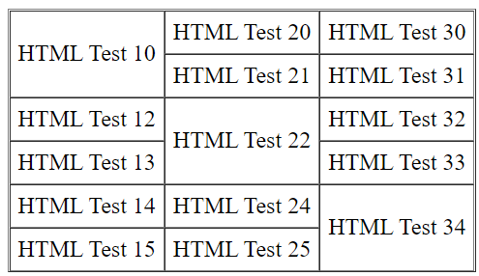

#-----------------------------------------------------------------------------------------------------------------------

2. Create 2 HTML documents say page1.html and page2.html each with 40 paragraphs. Each paragraph may contain

text, such as "Line 1", "Line 2".... "Line 40". Provide 3 links in page1 to take you to page2's top, center and bottom.

Provide 3 links in page2 to take you to page1's top, center and bottom.

#-----------------------------------------------------------------------------------------------------------------------

3. Write a HTML program and display the below image. When you click in Red area then it should show page1.html

Similarly Green to page2.html, Blue to page3.html and Yellow to page4.html

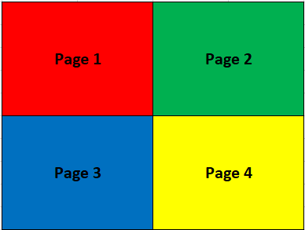

#-----------------------------------------------------------------------------------------------------------------------

Subject : CSS

#-----------------------------------------------------------------------------------------------------------------------

4. Write a HTML program, it should have 10 <h1> elements. 1st <h1> should show Heading 1, 2nd can show Heading 2 and so on,

the last will show Heading 10. Use the efficient method / short-cut method to style the elements as much as possible. Apply

the background color Green for all h1 elements except the 5th one with Heading 5. For the 5th <h1> give Blue Background color.

#-----------------------------------------------------------------------------------------------------------------------

5. Write a HTML program, Create about 10 different HTML elements such as h1,h2,h3,h4,h5,h6,p,div, simple table of 2 by 2 and pre

Use the efficient method / short-cut method to style the elements as much as possible. Apply border with 1 pixel, solid and Red

for all elements. Remove margin for all elements except the div element. Apply left margin to 20 pixel, right margin to 20 pixel,

top margin to 10 pixel and bottom margin to 10 pixel for that div. For all the elements simply give few words to identify.

#-----------------------------------------------------------------------------------------------------------------------